# 

**5.1: Static Strength** **3**

**5.2: Stress Concentration** **3**

**5.3: Failure Theories** **3**

**5.4: Maximum Shear Stress Theory** **3**

**5.5: Distortion Energy Theory** **4**

von Mises stress 4

**6.7: Stress Life Method and S-N Diagrams** **5**

Estimating endurance limit 6

Estimating the fatigue strength at N=103cycle 6

Basquin’s equation 7

**6.9: Endurance Limit Modifying Factors** **8**

Surface factor ka 8

Size factor kb 9

Load factor kc 10

Temperature factor kd 11

Reliability factor ke 11

**6.10: Stress Concentration and Notch Sensitivity** **12**

**6.12: The Fluctuating-Stress Diagram** **14**

Goodman line 14

**6.13: Fatigue Failure Criteria** **15**

Morrow 15

Gerber 15

Soderburg 16

ASME-Elliptic 16

Smith-Watson-Topper 16

Walker 16

**6.16: Combinations of Loading Modes** **17**

**7.4: Shaft Design for Stress** **17**

Shaft stress 17

For round rods with circular cross section 18

Goodman 18

Stress concentration estimates 19

**7.5: Deflection Considerations** **19**

Shaft redesign for less deflection 20

**Gears** **21**

**14.1: The Lewis Bending equation** **21**

Rearranged to: =WtFpy 22

Velocity factor 23

Fatigue factor 24

# 

# 

# 5.1: Static Strength

* + Strength for constant loads

# 5.2: Stress Concentration

* + A highly localized stress
  + K constants in Table’s A-15

# 5.3: Failure Theories

* + Ductile material (yielding is failure)
    - Maximum Shear Stress (MSS)
    - Distortion Energy (DE)
    - Ductile Coulomb-Mohr (DCM)
  + Brittle material (ultimate fracture is failure)
    - Maximum Normal Stress (MNS)
    - Brittle Coulomb-Mohr (BCM)
    - Modified Mohr (MM)

# 5.4: Maximum Shear Stress Theory

* + If
    - Design equations
  + If
  + If

# 

# 5.5: Distortion Energy Theory

## von Mises stress

* + - For plane stress ():
    - In terms of loading, not principle stresses
      * For plane stress ():
  + Design equation
  + For pure shear:
    - which is similar to what MSS found

# 6.7: Stress Life Method and S-N Diagrams

* + For constant amplitude stresses (everything we will look at)
    - maximum stress
    - minimum stress
    - mean stress
    - stress amplitude
  + S-N Diagram
    - Fatigue strength vs number of cycles to failure
* 6.8: Idealized S-N Diagram for Steels
  + 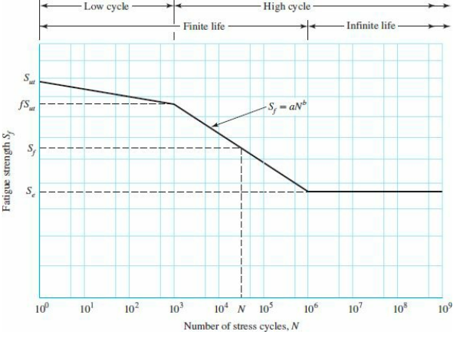

## Estimating endurance limit

* + - if
    - If
    - If

## Estimating the fatigue strength at cycle

* + - If
    - If
    - Or look at the figure
    - 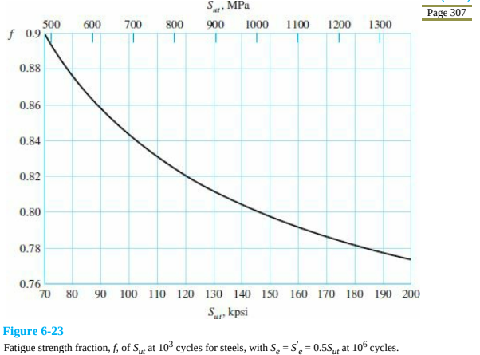
    - If lower than what's given on the graph,
  + The high cycle S-N line ()

## Basquin’s equation

* + - * For completely reversible stress
        + Or

Where is the fatigue strength coefficient

# 6.9: Endurance Limit Modifying Factors

## Surface factor

* + - 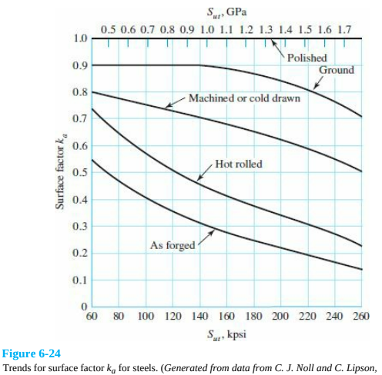
    - Or where:
    - 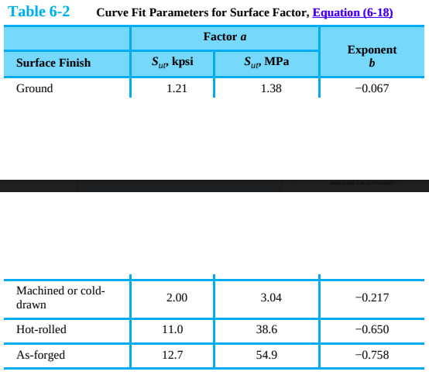
    - 

## Size factor

* + - Bending and torsion of a round rotating rod
      * 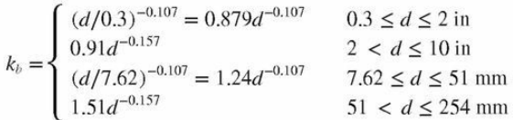
    - Axial loading
    - Not rotating rod
      * Used effective diameter for
      * 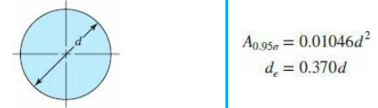
      * 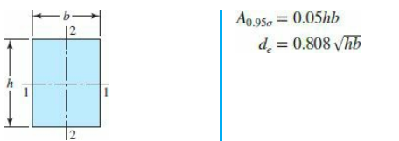
  + 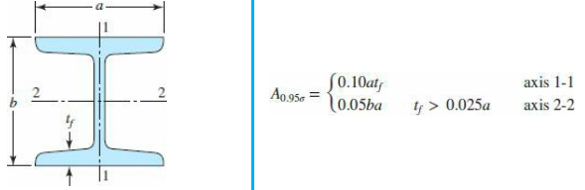
  + 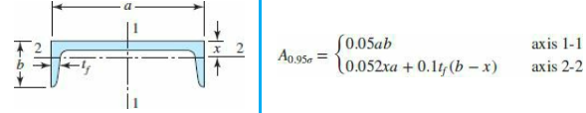

## Load factor

* + - If purley bending load
    - If purley axial load
    - If purley torsional load

## Temperature factor

* + - If values for are not tested for the operating temperature
      * Where is strength at our temperature and is at room temperature
    - Fahrenheit
    - Celcius

## Reliability factor

* + - 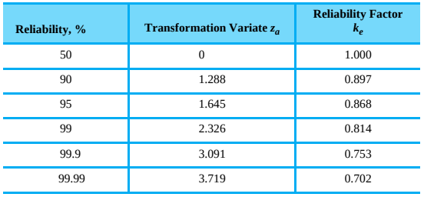
  + Other effects
    - Corrosion
    - Electrolytic plating
    - Metal spraying
    - Cyclic frequency
    - Frettage corrosion

# 6.10: Stress Concentration and Notch Sensitivity

* + Fatigue of notch free fatigue of notched
  + Notch sensitivity
    - is the static stress concentration factor
    - Rearranged:
  + 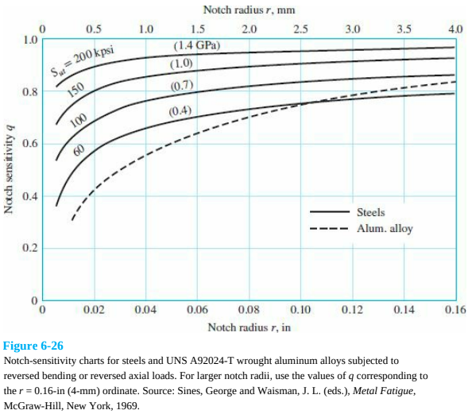
  + 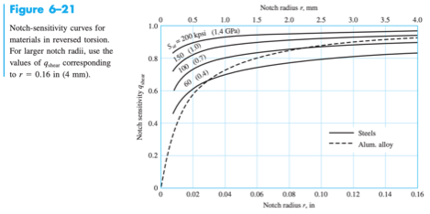
    - Or use Neuber Constant
      * is notch radius
  + 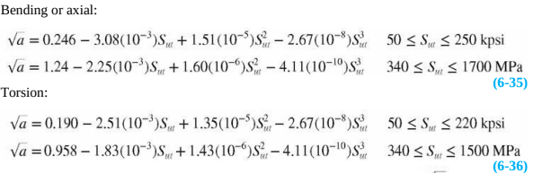

# 6.12: The Fluctuating-Stress Diagram

* + Non zero

## Goodman line

* + - Design equation ( is fatigue factor of safety)

      * Fairly conservitive method
      * Also check yielding for the maximum stress

# 6.13: Fatigue Failure Criteria

* + 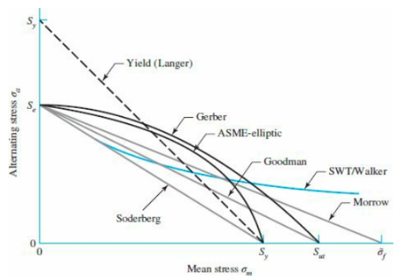
    - These tell us if there is an endurance limit/factor of safety but cannot determine specific number of cycles to failure
  + We already did Goodman

## Morrow

* + - Design equation

## Gerber

* + - Design equation

      * Fits the data well which means sometime it overestimates

## Soderburg

* + - Design equation

      * Uses yield so it is ultra conservitive

## ASME-Elliptic

* + - Design equation

      * Sometimes conservitve

## Smith-Watson-Topper

* + - Design equation
      * Theory based equation

## Walker

* + - Design equation
      * 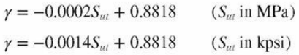
      * Adjust the theory from SWT method

# 6.16: Combinations of Loading Modes

* + Use von Mises stress
    - Stress concentration applies to each individual stress, not the general von Mises stress
    - no matter what the loading is

# 7.4: Shaft Design for Stress

* + Critical stress locations
    - Largest bending moment
    - Where torque is present
    - At stress concentrations

## Shaft stress



### For round rods with circular cross section

* + - * Let:
      * Circular rod design equations shortcut

### Goodman

* + - * + Morrow
        + Gerber
        + SWT
        + Yielding

## Stress concentration estimates

* + - Approximating and *Note this is static factor

|  | Bending | Torsion | Axial |
| --- | --- | --- | --- |
| Sharp shoulder fillet () | 2.7 | 2.2 | 3.0 |
| Rounded shoulder fillet () | 1.7 | 1.5 | 1.9 |
| End-mill keyseat () | 2.14 | 3.0 | --- |
| Sled runner keyseat | 1.7 | --- | --- |
| Retaining ring groove | 5.0 | 3.0 | 5.0 |

# 7.5: Deflection Considerations

* + Ensure bending of rod doesn’t ruin bearings
  + Max slope at bearing for different types
    - Should be anywhere between those 2 values

| Tapered roller | 0.0005-0.0012 rad |
| --- | --- |
| Cylindrical roller | 0.0008-0.0012 rad |
| Deep-groove ball | 0.001-0.003 rad |
| Spherical ball | 0.026-0.052 rad |
| Self-align ball | 0.026-0.052 rad |
| Uncrowned spur gear | <0.0005 rad |

* + - Max sure to sum individual slopes
    - Max deflection to ensure gears still work

| Spur gear with P < 10 teeth/in | 0.010 in |
| --- | --- |
| Spur gear with 11 < P < 19 | 0.005 in |
| Spur gear with 20 < P < 50 | 0.003 in |

## Shaft redesign for less deflection

* + - * is the design factor
      * is allowable deflection at that point

# Gears

* + 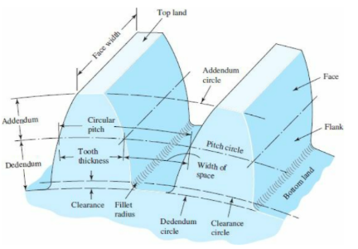

| Number of teeth | N |  |
| --- | --- | --- |
| Circular pitch | p |  |
| Module | m |  |
| Diametrical pitch | P |  |
| Addendum | a |  |
| Dedendum | b |  |
| Pitch diameter | d |  |

# 14.1: The Lewis Bending equation

* + Bending stress in gear teeth
    - * is the transmitted force
      * 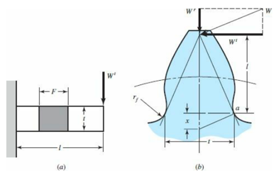
      * The tooth in fig (b) approx the cantilever in (a)

## Rearranged to:

Y is the lewis form factor

diametrical pitch

* + - * 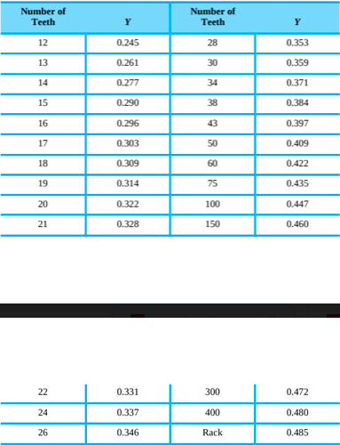

## Velocity factor

* + - * V is the pitch-line velocity ft/min
      * 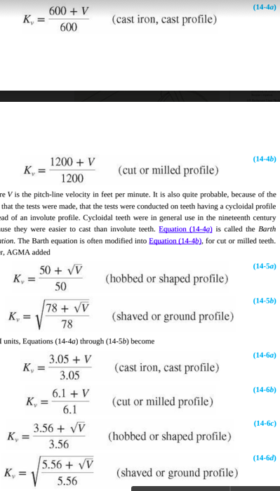
      * 
      * 

## Fatigue factor

* + - * + is the pressure angle
        + is the fillet radius
        + is the dedendum
        + is the pitch diameter